Monthly Growth Fixed Deposit Account
KBZ Bank has introduced Monthly Growth Fixed Deposit Account, which stands out from other regular fixed deposit accounts in the way that the interest is liquidated monthly, ensuring regular earnings for account holders before account maturity.

Eligible Customers
The following types of customers can open the Monthly Growth Fixed Deposit Account:
. Individual accounts
. Joint accounts
. Corporate/association and business accounts

Earn Interest Monthly
Enjoy the benefit of earning interest monthly, providing account holders with regular income and greater financial flexibility.

Minimum Initial Deposit
Minimum Initial Deposit for Individual/Joint – 10,000 MMK
Initial Deposit for Corporate/Association – 100,000 MMK

Deposit and Withdrawal
Open customer-preferred Monthly Growth Fixed Deposit Account types by transferring funds from any ordinary or special cash Call, Current or Savings Deposit Accounts. Similarly, funds upon account maturity are transferred to the designated ordinary or special cash Call, Current, Savings Deposit Account according to Monthly Growth Fixed Deposit Account Types.

Terms of deposit and interests
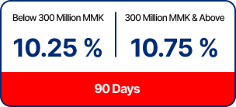
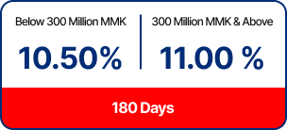

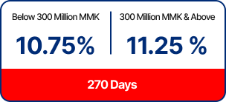
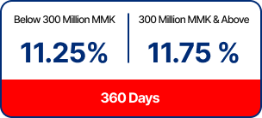

Primary Benefits
Earn Interest Monthly
Interest is earned monthly, ensuring regular earnings

Flexibility
Use any Cash/Ordinary Call, Current or Savings Deposit Account as “Monthly Interest Payout Account”.

Applying Loan Against Fixed Deposit
Need urgent cash? You can apply for an instant loan using your Fixed Deposit (FD) as collateral via i/mBanking. Applications are accepted up to 3 days before your FD matures.
– Minimum Fixed Deposit Balance: 6,250,000 MMK
– Account Type: Individual FD accounts only
– Minimum Loan Amount: 5,000,000 MMK
– Maximum Loan Limit: Up to 80% of your FD balance (available in up to 2 applications)

